Anna Kendall
Professor Hall
Retail Fashion Lab
30 October 2025
Comparison Shopping Report
Karyukai is a fashion brand inspired by the traditional Japanese artform and history, from woodblock prints of Ukiyo-e to cultural icons of Geisha, Samurai, and Kabuki theatricality. Four collections are offered: “Geisha-chic” evening wear, Professional Wear, Senshi (Warrior) Collection, and Kimono-inspired Outerwear. Each collection brings a unique representation of grace, elegance, power, discipline, and beauty that captures the essence of Geishas and Samurai warriors through color, style, and textile.
The ideal customers are women who actively seek extraordinary pieces to add to their wardrobe collection, particularly statement items that communicate greater self-expression and celebrate a rich ethnic cultural history. Because Karyukai aims to utilize the highest craftsmanship and material within the collection’s construction, most price points will have a premium and prestige pricing to reflect the excellent quality meant to last a lifetime. With that in mind, the best demographic for this brand are young established professionals with a comfortable higher end income who are also ambitious, driven, and actively seeking to move up in their career. Another type of a potential target market are women who are within a higher income base and also are avid collectors, history and cultural enthusiasts, and enjoy traveling and immersing themselves in other ethnic worlds. This range of customers are anticipated to be the most likely to appreciate Karyukai’s collections, its craftsmanship, and the higher prestige price ranges that indicate mastery of quality.
Across the collections, the colors, styles, and textiles stem from a variety of sources: current trends, evolving styles from traditional Japanese fashion, and the early revolutions in modern fashion from pioneer designers such as Vionnet, Poiret, and Balenciaga. Color palettes selected reflect the natural pastels seen in scenic landscapes, cherry blossoms, and florals, as well as prominent statement colors such as deep red taken from the iconic Japanese sun symbol, deep blue of the sea and mountain imagery, and earthy greens that currently trend amongst earth tones while also reflecting rich colors of the forest. Most silhouettes of each piece showcases either a relaxed, straighter line that evolved with Vionnet’s designs in the 1910s and 20s or a belted, blouson, wrap silhouette style inspired by the kimono shape. Textiles are aimed to give a traditionalist impression with a strong utilization of silks, linen blends, and natural fibers to give a greater immersive experience in Japanese fashion of the Edo Period. These elements are anticipated to appeal to the target customer based on expressive qualities of color, refined and elegant styles that derive from timeless classics, and on how textiles offer a deeper connection towards an elevated multicultural experience.

Geisha-Chic Evening Wear Collection
This collection is meant to offer unique, expressive pieces that dazzle and reflect the essence of feminine beauty found in a Geisha. For inspiration, Haute Couture, luxury Ready to Wear collections, and mass-consumer retailers such as Macy’s, Kohl’s, Anthropologie, Target were used to inform stylistic choices of Karyukai’s eveningwear collection. Examining haute couture collections which can be an ideal source of forecasting and predicted greater trends of the season, the particular collection I found most helpful as a resource was Vera Wang’s Haute Bridal Collection; Vera Wang having a rich background and strong connection with her Asian heritage seemed like the perfect designer to draw from. In general, Vera Wang’s bridal dresses typically start at the high $1000s, and can often exceed $10,000 in price, especially being custom made to order pieces.
Two dresses from Vera’s designs that were most influential to Karyukai were the Georgia Dress of her 2026 collection and the Organza muted peach bridal dress from Fall/Winter 2019. While pricing information is unavailable for these pieces, they are likely to fall in the higher range of Vera’s Haute Bridal Couture, with the ideal consumer being women of high income, likely top 1-5%. What I particularly loved about these dresses was luxurious material, color, direct stylistic references to both Vionnet’s innovative designs and fashion of royalty through modest straight silhouettes that harken back to the simplicity of medieval fashion, as well high collar lines that reflect regality, discipline, and refined elegance reminiscent of historic female queens and empresses. 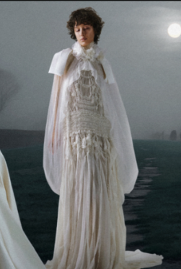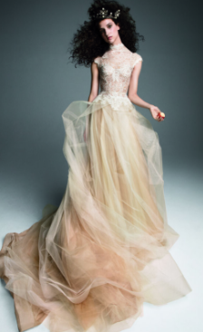

The textiles used include organza, lace, chiffon, silk, and tulle (particularly Italian silk Tulle for the Georgia dress), all of masterful quality and high craftsmanship. As a planner in setting wholesale costs, my aim is to find a target balance between high quality and affordability so that the collections are not exclusive to only those with extraordinarily high incomes. Karayukai’s purchasing for evening wear is aimed to strategically invest in quality where it is most impactful for the experience of the garment, while keeping costs modest within the high hundreds range at most to still remain accessible to a younger professional market that is still in a phase of building their financial livelihood. For example, high quality bridal acetate may serve as a substitution for silk for pieces that are less formal.
The chinese collared dress (Style #A1ST56-1) is the prestige piece in this collection (each collection features at least one statement piece that is priced at the top end of Kayukai’s offering, $800-1000 range). Similar to Vera’s haute couture bridal dresses, this dress strongly reflects historical Chinese fashion made recently trendy over the past few decades through cultural revival by notable designers such as Lagerfeld who incorporated traditional Chinese wardrobe into western luxury fashion. This dress will also be similar in how it incorporates high quality textiles of silk brocade that celebrates the craftsmanship in traditional silk fabricwork.
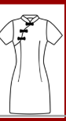

Another dress that inspired Karyukai’s evening wear is Armani’s Mulberry Silk Draped Dress, featured in the Autumn/Winter 2025-2026 Collection. This dress, while simple, represents a timeless classic style priced at $3995.00 and made of 100% silk. Its silhouette immediately reminded me of a Geisha’s kimono, while featuring a cross-style of traditional Japanese wardrobe in its conservative simplicity and plainness. The decision behind Karyukai’s Belted Cocktail Dress (A1P10-2) was modeled after Armain’s Mulberry silk dress, with amendments to bring affordability in pricing. The same shade of purple would be used – muted and a somewhat desaturated deep purple with blue undertones.
Another reference piece that has influenced this cocktail dress is Anthropologie’s Somerset Long Sleeve Mockneck Chiffon Maxi Dress in pink floral. For patterning and textile, Kayurkai’s Cocktail dress would similarly match the chiffon and floral pattern choices. Chiffon would replace silk as the textile for greater volume in flow and drapability while also carrying a formal elegance. This may significantly affect the price point and allow for it to be set in the low to mid hundreds range, rather than the mid thousands. As a comparison in price, Anthropologie’s dress is priced starting at $177, which is far more ideal range for Kayukai’s pricing strategy and target demographic; the switch in textile allows for this type of pricing flexibility. The cocktail dress will also closely mimic Anthropologies in floral pattern, aiming for natural, semi-realistic florals that convey feminine beauty.
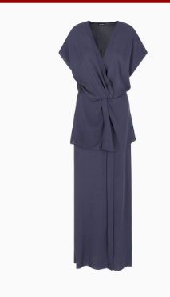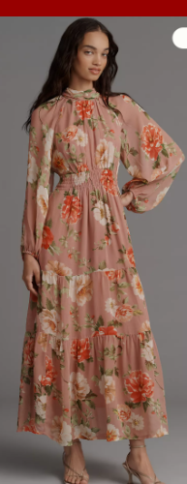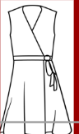

At a lower end discount retailer range, dresses that range in price between $20-60 are beyond the lower bound of the products that Karyukai offers; however, these styles are helpful in seeing which trends are most popular and what sticks with consumers as stylistic elements trickle down from luxury fashion lines. An example of this is a dress from Vera Wang’s Simply Vera line that is a very close influence of the Linen Day Dress (A1P34-3) with a loose flowy silhouette, a style that can easily be attributable to Vionnet’s revolutionary kimono-inspired designs. Old Navy’s pink dress features a textile pattern that is reminiscent of cherry blossoms, with stylistic choices of garment construction, silhouette, and trimming that can be seen in the Karyukai’s Spring Lacy Silk Dress (A1R1-5). In both examples, textiles would be elevated to high quality linen for the day dress and bridal acetate rather than polyester for the lacy silk dress, so that the overall idea of trends are kept but that the quality of textile is consistent with high quality standards of Karyukai’s brand.

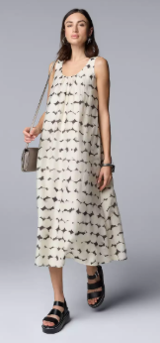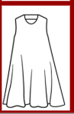
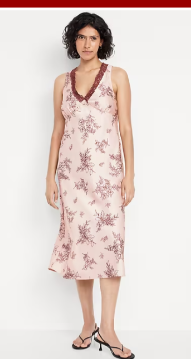
Ultimately, the direct industry inspirations guide the trend and styling behind Karykai’s fashionable looks, taking on influence from traditional Japanese fashion, the Japonisme movement, and evolutions of modern day styles from Vionnet and Poiret who defined 20th century women’s fashion. These sources inform color, textile, pricing choices that center around a target demographic, balancing high quality with moderate affordability for a consumer base of young professionals seeking to grow themselves and their careers with a wardrobe of grace, elegance, and power by their side. While all Karyukai collections reflect this, the Geisha inspired evening wear in particular showcases the greatest amount of influence between industry inspiration and brand creation.

