Anna Kendall
Professor Hall
Retail Fashion Lab
2 November 2025

Karyukai x Tatcha x Apothekary Event Collab

Objective:
Celebrating Japanese culture through products that truly capture and immerse the customer in the traditional Japanese experience, combining high quality luxury with Japan’s finest ingredients, textiles, and rituals.

This event is a collaboration meant to boost name recognition of all three partners, using names of familiarity and elevating those brands with a greater immersive experience in Japanese culture. Ideally, this would not only drive long-term sales but also would increase the hype and potential virality of these brands with younger demographics. Through stunning event visuals that leave a lasting impression, the aftermath of the styling event is meant to be highly talked about and shared on a widespread scale.

Event Plan:
When:
I believe late spring would be the best time for this event, probably later in May. Late spring is in line with the tail end of cherry blossom season, a remarkable period of florals that is custom to Japan’s natural landscape. This part of the season is also late enough where late summer (August) previews are

Venue characteristics:

For location, I have two recommendations for areas: SoHo and Hudson Yards 34th street.

SoHo NYC would be ideal being close to the fashion shops by Spring Street and the target demographic of women living in this area, the village, TriBeCa – young millennial age rage, professionals with an established income, willing to spend money on quality and are comfortable living in more expensive neighborhoods, seeking wardrobes with unique garments for essentials and statement pieces. Aside from 5th Ave, SoHo is one of the most popular fashion neighborhoods in NYC, featuring boutiques, designer shops, and venues home to larger fashion events. This location would elevate the experience with a high-end demographic and be central to a bustling fashion industry that’s driven by newness and innovation.
While this may be one option for this event, a specific venue that might be an even better fit is in Hudson Yards-34th Street. Not too far from the garment district, Times Square, or FIT, Hudson Yards has been a relatively new development (over the past 10 years, truly gaining popularity after the last 5). In the area is a giant modern shopping center with both luxury and unique stores and dining, as well as a newly iconic nyc landmark, The Vessel, a 16-story structure of stairs that resembles a beehive, representing the essence and architectural trend of organic modernism. To me, this area represents a place with potential, re-invention, and what the future has to bring.
The other key advantage to mind is cost of space. Given the density of population and buildings, SoHo could very well be a fortune to afford a venue with a large space, wherein Hudson Yards, renting the same amount of square footage could be very moderate.

When looking for a specific look, Triangle Loft Meatpacking has exact interior vibe I’m interested in—a feeling of history and character in the construction through the wood ceiling beams that is reminiscent of a traditional Japanese house through past centuries. As for location, I would ideally like a neighborhood more central to fashion and high end retail (I would describe Chelsea as more of a tourist/food area), but this loft is in Manhattan which would be my preference. I would argue that seeking a loft in Queens or Brooklyn would be reaching the wrong demographic (hipster, can be overly price conscious which could turn potential customers away from the brand), but those areas would have ample amounts of space and character in their event spaces.

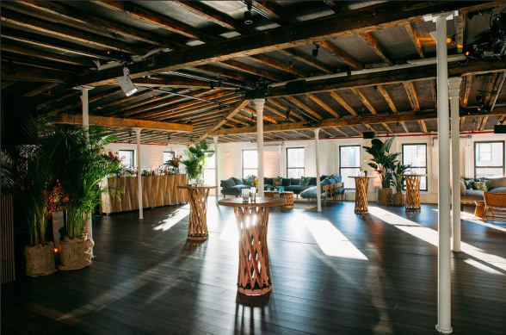

Ultimately, the decision would land on a balance of cost, neighborhood area of maximum potential of outreach to new clients to generate the desired hype and landing the right look to emphasize a detail-oriented branding experience. Further research would be needed to land the perfect space, but at least these factors that are laid out act as a guide for continued research.

Event Design and References:
Following inspiration from Hermes’s New Orleans Opening (left) and Eataly’s spring installation (right):
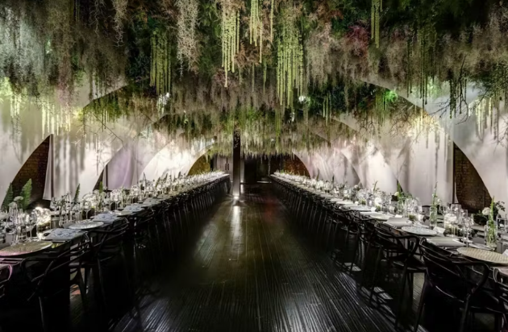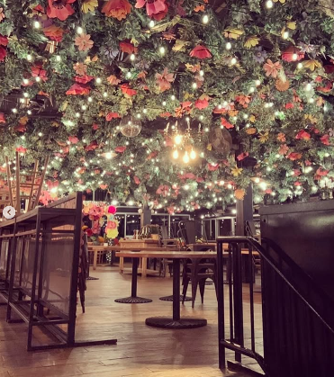

My ideal event space would follow the theatrical and immersive experience that the designers of the events above successfully created. When looking up Karyukai on an image search, this was the first image that came up and is one that I would love to be recreated for the event:
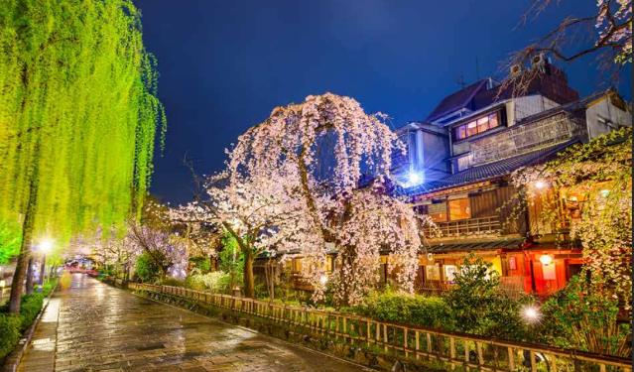
Event Activities:
This brand collab is meant to garner exposure and generate hype, so the format will be a branding showcase from each partner, as well as a mini launch featuring a new product from each brand exclusive to those attending the brand. Traditional Japanese tea and Apothekary branded beverages will be served. The menu will feature unique Japanese cuisine (Thirteen Water is a restaurant that comes to mind—incredibly innovative and interesting sushi that takes creativity to a new level) to highlight the immersivity that all brands in the partnership work tirelessly to achieve.
Karyukai would host a private collection showing of highlights from Geisha evening wear, Senshi warrior, and professional collections. Will offer first pre-ordering opportunities to guests, and an auction or raffle away a custom made garment of the winner’s choosing based on the collections
Apothekary is a brand that offers zen herbal supplement drops as a healthy beverage alternative that comes with many benefits. I think it would be great if they launched a new flavor exclusive to try at the event.
Tatcha is a luxury skincare company that deeply invests in the details of Japanese rituals within their brand, even to the point where they offer special traditional slik face cloths to add to a skincare routine. I think they could benefit from demonstrations of their products, their silk, water, dewy skin cream lines and moisturizers to showcase the level of quality. Maybe a raffle or auction for product gift sets could be something of interest for them, and/or something they can offer as a sample to everyone. This could include a launch of a hand cream as an example, primarily so that exposure of the brand increases.

Entertainment:
I would be interested in supporting local Japanese musicians to play traditional Japanese music
The emphasis is on the Geisha figure for the event, so I would highlight this as much as possible, and ideally through the entertainment portion.
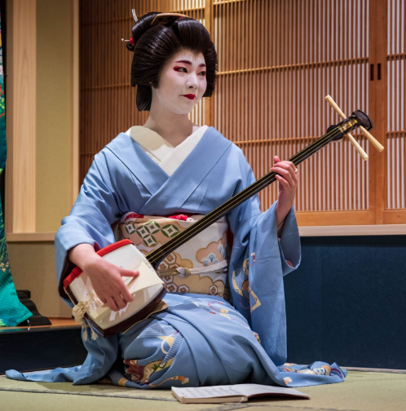

Step and Repeat will be available for photos and press
Raffle events (potentially ones where entry is based on social media share and tagging), Silent Auctions

Costs:
Attendance allowance: 100 guests ideally

Major costs to be accounted for:
Venue: 5,000 (accounting for time needed for install) – based on an average $300/hr rate for a loft space
Event Installation: $10,000 (includes material and install labor)
Event Labor: $10,000 (rough estimate, could include promotional costs)
Food: $40 pp (based on Thirteen Water’s $85 pp/13 courses rate)
Brand Sampling: Combined -- $20 pp
Entertainment: $800/hr as the approx. upper limit – potential 2-3 hours of booking
Advertising: $850/month, starting one month prior to the event. Advertising focus on social media (Instagram, tik tok, facebook)

Totals:
$35,050 – baseline (would be adjusted with further research)
Ticket costs needed to charge for at minimum: $350
Opportunity in greater profit in auction activity and product sales at the event

Advertising:
Aiming for simplicity and zen as an extension of all three brand messaging
Karyukai logo – calligraphy-like, expressionistic brushstrokes with watercolor cherry blossom, highlighting visual artistry. Clean lightweight typography to give high end feel
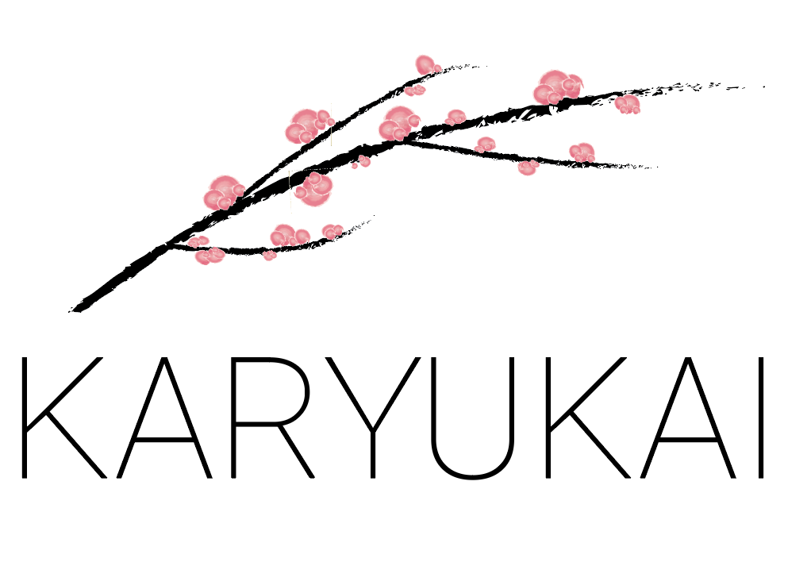

Collab mockup:
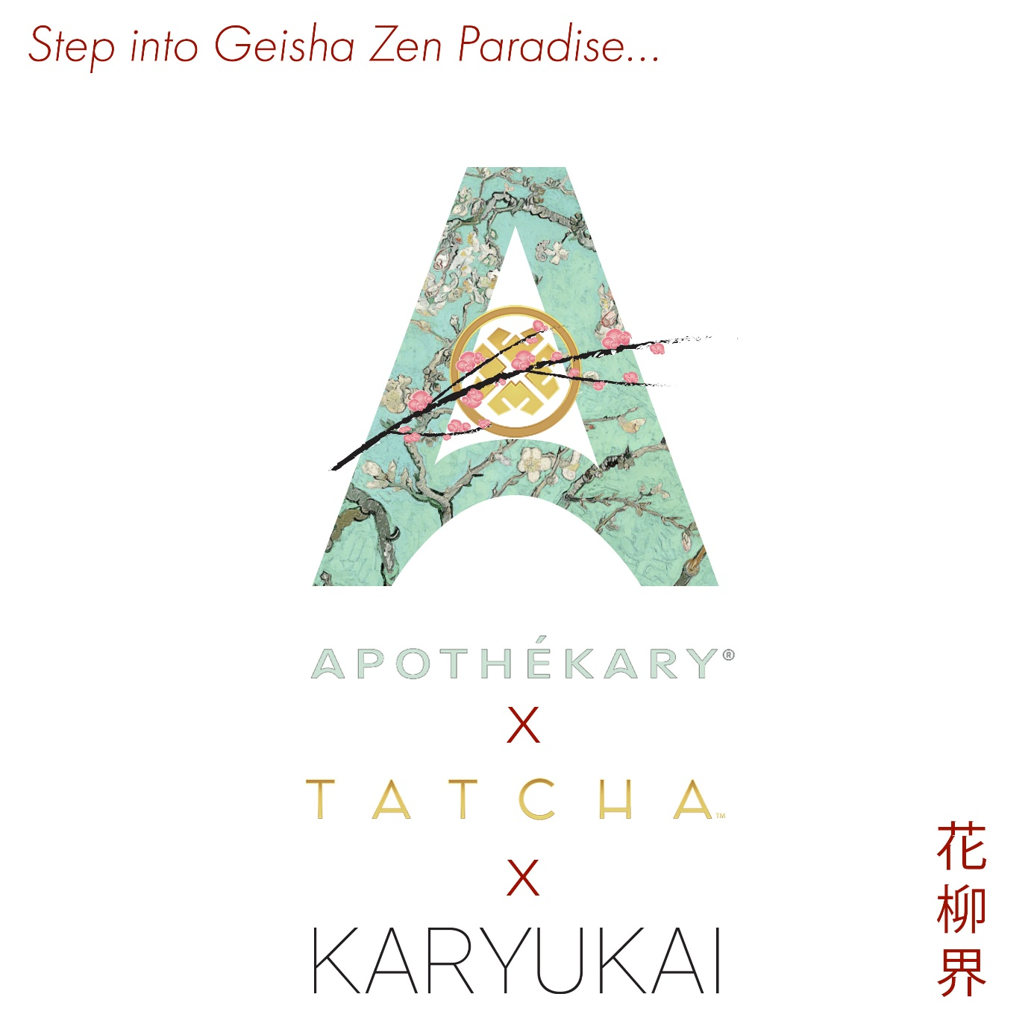
Visual combination of all three logos of partnership to illustrate zen and harmony between three different approaches to capturing essence of Japanese culture

Personnel:
Brand ambassadors
Servers, Apothekary mixologists
Caterers (Japanese cuisine)
Traditional Japanese band
Models for style showcase
Installers prior to the event
Any promoters/influencers (big names in fashion for example)
Event staff
Security

